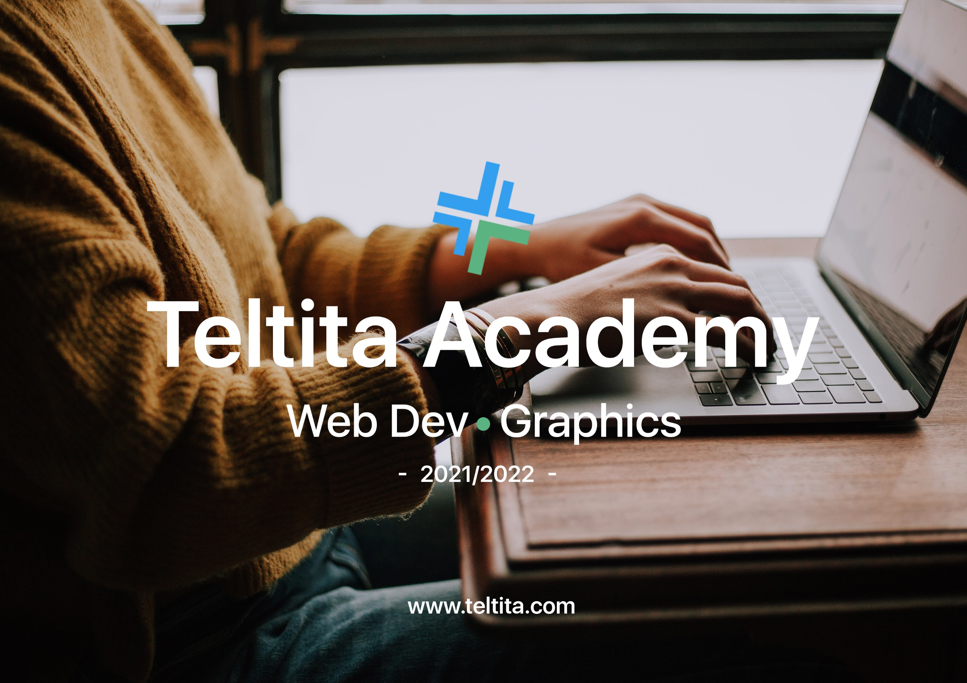

**WEB DEVELOPMENT (FULL STACK)**

Software: Visual Studio Code (<https://code.visualstudio.com/download>)

Web browser (Opera, Firefox, Chrome, Microsoft Edge, Safari)

1. Frontend

HTML – Hypertext Markup Language

CSS – Cascading Style Sheet

JavaScript

2. Backend

JavaScript (Node.js)

3. Version Control System (Git) – Github

4. Building a Designer’s Mentality

**GRAPHIC DESIGN   
Outline**

Design PrinciplesTypography  
Fonts  
Colours  
Layouts  
  
Photoshop Tutorials  
Illustrator Tutorials  
  
Flyer Design  
Logo Design  
Branding  
Content Creation  
 **Bonus**Animation (After Effects)  
 **Resources  
Softwares**1. Photoshop  
<https://bit.ly/3m2f0hB>  
  
2. Illustrator  
<https://bit.ly/3dTjRgx>  
  
3. Aftereffects  
<https://bit.ly/3pVB52r>  
 **Websites**1. Google Fonts  
[https://fonts.google.com/](https://fonts.google.com/?authuser=0)  
  
2. Adobe Fonts  
<https://fonts.adobe.com/>  
  
3. Unsplash  
<https://unsplash.com/>  
  
4. Pexels  
<https://www.pexels.com/>  
  
5.Flaticons  
<https://www.flaticon.com/>  
  
6. Freepik  
<https://www.freepik.com/home> **PARTICIPANTS**

1. Graphic Design – 9 students

2. Web Development – 5 students

**MEETING TIMES**

1. Frequency: Twice a week

2. Days:

Saturday:

8:30am – 10:30am (Graphic Design)

12pm – 2pm (Web Development)

Sunday:

3pm – 5pm (Web Development)

6:30pm – 8:30pm (Graphic Design)